Optimization of process conditions and kinetic microbial growth for milk fermentation using domestic kefir grains from Costa Rica
Isabela de Sainz^{*1}, Mauricio Redondo-Solano†, Godofredo Solano~ and Lautaro Ramírez⁺
*Engineering Research Institute and Department of Industrial Engineering, University of Costa Rica, San Jose
† Research Center of Tropical Diseases (CIET) and Laboratory for Research and Training in Food Microbiology (LIMA), Department of Microbiology and Immunology, Faculty of Microbiology, University of Costa Rica, San Jose 11501.
+ Department of Chemical Engineering University of Costa Rica, San Jose
~ Nuclear Magnetic Resonance Unit, Natural Product Investigation Center, University of Costa Rica, San Jose, Costa Rica 11501
¹Corresponding author: isabela.desainz@ucr.ac.cr, (506) 2511-5263.
Kefir, a fermented milk product, differs from yogurt due to its unique microbial composition, offering a broad spectrum of health benefits. Given its global popularity and high cost, there is a significant trend towards domestic kefir production. This study explores the optimization of kefir fermentation using Costa Rican domestic kefir grains, assessing the effects of temperature, agitation, and initial starter culture concentration. A Central Composite Rotatable Design (CCRD) and response surface statistical approach were employed to evaluate these parameters. Microbial growth data was fitted into a quadratic model, revealing significant interactions, particularly with temperature affecting both lactic acid bacteria (LAB) and yeast populations. Optimized fermentation conditions were established at 25°C, 0 rpm, and 5 g/L initial biomass, under which final microbial populations reached 9.45±0.13 log(cfu)/mL for yeast and 9.23±0.06 log(cfu)/mL for LAB. The specific growth velocity for kefir biomass was 0.029 1/h and the total acid production rate was 0.060 g/(L h). Notably, the acetic acid production was significantly less than lactic acid, indicating a dominance of LAB over acetic acid bacteria, which is crucial for the desired flavor and health benefits of kefir. Additionally, microbial enumeration on GYC and Rogosa agars showed distinct colony formations, highlighting the complex microbial interactions within kefir. This comprehensive dataset suggests that the performance of non-commercial starter cultures can be significantly improved under controlled conditions, providing a basis for developing guidelines for domestic kefir production. This study not only optimizes kefir production but also ensures that home-prepared kefir can meet quality standards, potentially enhancing its nutritional and therapeutic benefits.
Key words: Fermentation, Response Surface Methodology, kinetic modelling, microbial growth optimization, domestic kefir, quality, Costa Rican kefir, domestic fermentation.
Introduction
Kefir is a fermented milk product rich in probiotics that is different from yogurt and other types of fermented milks. Unlike yogurt, which is primarily fermented by lactic acid bacteria (LAB), kefir is an acidic, low alcohol probiotic drink derived from a synergistic complex mixture of bacteria (including lactic acid and acetic acid) and yeasts (Xiao, et al., 2023). This distinct combination of microorganisms imparts kefir with a unique flavor, texture, and a broad spectrum of health benefits such as lowering blood pressure (Silva-Cutini, et al., 2019), anti-cancer (Sharifi, et al., 2017), anti-viral (Hamida, et al., 2021), anti-diabetic (Salari, et al., 2021), anti-inflammatory (Chen, et al., 2020) and immunity-boosting (Patil, et al., 2021) properties.
Lactic acid bacteria (LAB) are crucial microorganisms in producing fermented dairy products like kefir. In kefir, LAB develop as a community (Melkonian, et al., 2019), interacting with yeast through processes like lactic acid assimilation (Cheirsilp, Shoji, Shimizu, & Shioya, 2003) (Tada, Katakura, Ninomiya, & Shioya, 2007), production of CO2/removal of O2 (Bai & Rai, 2011) (Sieuwerts, Bron, & Smid, 2018) and nutrient generation for bacteria (Ponomarova, et al., 2017) (Stadie, Gulitz, Ehrmann, & Vogel, 2013) (Demirhan, Apar, Payer, & Belma, 2011). However, in natural starter cultures, the microbial community is complex and challenging to study due to the presence of thousands of species, with a significant portion belonging to lactic acid bacteria (LAB), but also including yeasts and acetic acid bacteria (AAB) (Kabak & Dobson, 2011) (Arslan, 2015).
In recent years, kefir has become a popular product in many countries, with a global market size of $1.73 billion in 2022, and a projected growth to $2.19 billion by 2026 (Spizzirri, Loizzo, Aiello, Prencipe, & Restuccia, 2023). Costa Rica, with one of the largest per capita consumptions of milk and milk products in Latin America (Ministerio de Agricultura y Ganaderia), has also seen a rise in kefir’s availability as a commercial product.
Given kefir`s increasing popularity, and high cost (Roy Choudhury, 2024), there is an increasing trend of domestic production. It means that is critical to understand the performance of “second and more” generation starter cultures, especially regarding quality assurance. Microbial composition changes during fermentation (Gao & Zhang, 2019), and household practices introduce variability which can lead to the modification of the growth parameters, making necessary a controllable and simplified household fermentation process.
Optimization of kefir fermentation involves assessing microbial growth (Gao, et al., 2012) while adhering to quality standards set by the Codex Alimentarius. Key factors affecting fermentation include temperature, agitation (oxygen presence), and concentration of starter culture (Gupta, Cox, & Abu-Ghannam, 2010), (Mengesha, Tebeje, & Tilahun, 2022). The application of models like Gompertz, Weibull and Monod help predict biomass concentration and system performance (Ibarz & Augusto, 2014). These techniques are valuable not only for industrial applications but for the design of cost-effective household methods.
This paper aims to describe the microbial growth and the optimization process during kefir fermentation using kefir grains of domestic origin. Variables with a direct impact in the general microbial populations present in kefir that are easily controllable in household environments (temperature, agitation and concentration of starter culture) (Adamberg, Kask, Laht, & Paalme, 2003), (Serra, Strehaiano, & Tailland, 2005) and (Gregory & Thornhill, 1997)), were considered. The use of a response surface statistical approach will generate data to demonstrate the best conditions for kefir fermentation within a domestic environment and determine if kefir produced under these conditions may comply with the minimal quality requirements established by the Codex Alimentarius (total LAB count and yeast count).
Materials and Methods
Inoculum and activation
Kefir grains used in this study were obtained locally from a Costa Rican household. The performance, stability, and activation after preservation of these kefir grains in comparison to commercial kefir grain starters was evaluated previously (de Sainz, Redondo-Solano, Solano, & Ramirez, 2020).
Fermentation experiments and microbial growth optimization
Each fermentation was performed using sterile 250 mL Erlenmeyer flasks containing 200 mL of total reaction volume, (200 mL of UHT milk; 2% fat, Dos Pinos). The milk was first heated to the temperature at which the fermentation took place (Table 1), then the activated grains were weighed and added to the tempered milk inside the Erlenmeyer. The containers were then placed in the grids of an orbital agitation incubation equipment (Shel Lab model SSI3, Sheldon Manufacturing In, Cornelius, OR) set at the desired condition. All fermentation experiments were performed for 24 h.
A Central Composite Rotatable Design (CCRD) planning with 8 factorial points 6 axial points and 6 central points, was used to optimize the total bacterial and yeast growth with the objective to achieve the quality requirements stablished by the Codex Alimentarius. Response Surface Methodology (RSM) was used to fit data into multivariable polynomial model through the conditions of the fermentations that were evaluated: temperature (to comment on presence of thermophilic and mesophilic LAB groups), agitation (changes of oxygen availability during fermentation) and the initial concentration of microorganisms (shows if there are competitive behaviors).
The temperature ranged from 25 °C (-α) to 45°C (+α), the agitation rate from 0 rpm (-α) to 100 rpm (+α) and the initial biomass from 1 g (-α) to 10 g (+α). The factorial points were 29 °C (-1) and 41 °C (+1) for temperature, 20 rpm (-1) and 80 rpm (+1) for agitation and 2.8 g (-1) and 8.2 g (+1) for initial biomass. The center points (·) were 35°C, 50 rpm and 5.5 g. This experimental design is shown in Table 1 (in this table the experiments are not randomized).
Bacterial and yeast growth were the response variables. To determine growth, the difference between initial and final microbial population in log(cfu)/mL was determined. Results of the experimental design (Table 1) were evaluated and analyzed using the Design Expert 12 software (Statease, Inc.).
Culture Media and Gram staining
Lactic acid bacteria were quantified using De Man, Rogosa, and Sharpe (MRS) agar and Rogosa agar, while yeasts were quantified on potato dextrose agar (PDA) supplemented with chloramphenicol. Acetic acid bacteria were quantified using glucose-yeast extract calcium carbonate agar (GYC), with all media sourced from Oxoid Ltd; just the counts from the MRS agar were used to define optimized conditions. Ten-fold dilutions of the fermentation mixture were prepared in 0.1% sterile peptone water. A volume of 100 µL from the suitable dilutions was plated in duplicate on the respective media and incubated at room temperature. MRS and Rogosa plates were incubated under capnophilic conditions in glass containers for a minimum of 24 to 36 hours. In contrast, PDA and GYC plates were incubated aerobically for at least 48 hours, with PDA plates additionally shielded from direct sunlight. Also, Gram staining was conducted to discern the morphological characteristics of the colonies on the culture media plates.
Biomass growth and acid production
Biomass growth and total acid production experiments were conducted under the optimized conditions derived from the Central Composite Rotatable Design (CCRD). Each time point on the growth curve was treated as a separate fermentation experiment. Post-fermentation, a plastic strainer (mesh size 18) was sanitized in a laminar flow microbiological safety cabinet (BSC, Labculture Class I, Type A2, E-Series; Esco Micro Pte. Ltd., Singapore) using 70% ethanol. Kefir grains were filtered, rinsed through the strainer, and left to dry on paper filters within the cabinet. The dried grains were then weighed using a precision balance (Radwag model PS 2100 R1, Radwag USA LLC, Miami, FL). The filtered liquid (kefir) underwent titration to measure total acidity. To determine the dynamics of total acid production and biomass growth over time, various models were employed, including the logistic, Gompertz, and Richards equations. Biomass growth data was fitted to the modified Weibull equation (Eq. (1)), a model for growth kinetics and survival rates, as cited by (Pradhan, et al., 2012).
$$B=B_{max}-B_{i}\exp{(-k{\left(t_{a}-t\right)}^{z})}$$ | (1)
Where,
$B$, Concentration of biomass (g/L)
$B_{max}$, maximum biomass concentration (g/L)
$B_{i}$, initial biomass concentration (g/L)
$k$, form constant
$t_{a}$, cellular adaptation time (h)
The modified Gompertz equation (Eq. (2)) was used to model the lactic acid production expressed as total acid obtained from acid titration; this model is consistently applied to describe product formation according to Zajšek & Goršek (Zajšek & Goršek, 2010).
$$C=C_{max}\exp\left(-\exp\left(\frac{e^{1}r}{C_{max}}\left(t_{a}-t\right)+1\right)\right)$$ | (2)
Where,
$C$, Concentration of acid (g/L)
$C_{max}$, maximum acid concentration (g/L)
$r$, production rate (g/(L h))
$t_{a}$, cellular adaptation time (h)
Organic acid determination
A methodology similar to the one described by Rodrigues (Rodrigues, et al., 2024) was followed. The product was brought to room temperature, and an aliquot of 4 mL (approximately 4 g) was placed in a centrifuge tube, then centrifuged at 6000 rpm for 15 minutes. The supernatant was transferred to a new tube and centrifuged again, and finally, the supernatant was filtered through a 0.2 µm PTFE membrane filter. Subsequently, a 400 µL aliquot of the filtrate was mixed with 70 µL of a 4.0 mmol/L TSPNa solution and 130 µL of a 0.1 mol/L phosphate buffer solution at pH 7.4. The mixture was transferred to a 5 mm NMR tube and the 1H spectrum was measured at 600.13 MHz, at a temperature of 298K using the noesypr1d pulse sequence with an acquisition time of 4.5 s and a relaxation time of 15 s for 128 acquisitions with a spectral window of 7211.5 Hz and 65536 points. The concentration of specific metabolites was determined after phasing and baseline correction of the spectra, and comparing the integral values of identified metabolites signals to the integral of the TSPNa signal (0.0 ppm signal).
Results
The results from the Central Composite Rotatable Design (CCRD) are presented in Table 1, and the corresponding response surfaces are depicted in Figure 1. The experimental images demonstrate that maximum growth of bacteria and yeast occurs with a lower initial inoculum concentration, as illustrated in Figure 1a and Figure 1b.
In this study, we optimized conditions to maximize the growth of total Lactic Acid Bacteria (LAB) and yeast by the end of the fermentation process. The growth dynamics of LAB were effectively described by a quadratic second-order polynomial model (Eq. (3)), where T represents the temperature (°C), A denotes agitation (rpm), and C indicates the initial biomass (g). This model achieved a high correlation coefficient (R²) of 0.995, suggesting an excellent fit with the experimental data.
$$+2.24-0.38∙T+0.35∙A-0.66∙C+0.050∙T∙A+0.046 ∙T^{2}+0.32∙A^{2}+0.21∙C^{2}-0.38 ∙T^{2}∙A+0.14∙T∙A^{2}$$ | (3)
Similarly, yeast growth was modeled using a quadratic second-order polynomial equation (Eq. (4)), achieving a correlation coefficient (R²) of 0.9811 with the same variables. These models underscore the predictive strength of the parameters involved in the fermentation process.
$$+2.10-0.34∙T+0.36∙A-0.67∙C+0.029∙T∙A+0.056 ∙T^2+0.37 ∙A^2+0.29∙C^2-0.29 ∙T^2∙A$$ | (4)
To assess the nature of the optima obtained from the Central Composite Rotatable Design (CCRD), we conducted an analysis using RStudio 2021.09.1 (RStudio Ink), the results of which are presented in Table 2 and detailed in Appendix A. This analysis revealed that the biomass concentration (C) is at an overall minimum point for bacterial growth. In contrast, the other variables represent saddle points, suggesting they are local optima within the LAB and yeast growth models. These insights indicate that further exploration of each factor is necessary to determine the overall optimization points, ensuring the robustness of our findings and their applicability in optimizing fermentation conditions.
To validate the optimization conditions, experiments were conducted in triplicates, which demonstrated a logarithmic growth of LAB at [5.92±0.065] log(cfu)/mL. This result aligns closely with the predictions of Eq. (1), which estimated a growth range of [5.80 - 6.79] log(cfu)/mL within a 95% confidence interval. Similarly, the logarithmic growth of yeast was recorded at [6.42±0.14] log(cfu)/mL, consistent with the model in Eq. (2) that predicted a yeast growth range of [5.86 - 7.56] log(cfu)/mL for a 95% confidence interval. These outcomes affirm the reliability of the models under the specified experimental conditions.
Additionally, under these conditions, Gram stains performed were performed from colonies obtained from GYC, MRS, and Rogosa plates. The results showed only one colony on MRS and two distinct colonies on each of the GYC and Rogosa plates, with one at a lower concentration and another at a higher concentration, results are shown in Table 3. The staining on MRS agar showed the presence of Gram-positive cocci and bacilli. On Rogosa agar, the smaller colony consisted of both Gram-positive cocci and bacilli, while the larger colony was Gram-positive yeast. Similarly, the staining of the smaller colony on GYC agar revealed Gram-positive cocci and Gram negative bacilli, with the larger colony indicating the presence of Gram-positive yeast.
Results for the kinetics of biomass production under the optimized conditions (derived from the Central Composite Rotatable Design, CCRD) are presented in Figure 2 and Table 4. The data indicate that the maximum biomass concentration (g/L) is twice the amount of the initial inoculum used for the experiment, signifying a 94% increase in biomass at these conditions.
The kinetic curves for biomass growth and total acid production (primarily lactic and acetic acids) were derived under optimized conditions. Each experiment had a total volume of 200 mL with an initial biomass concentration of 5 g/L (1 g per 200 mL). Using Curve Expert Basic 2.0 software (see Fig. 2), the biomass growth data was fitted to the modified Weibull equation (Eq. (1)), which is utilized for modeling growth kinetics and survival rates, as referenced by Pradhan (Pradhan, et al., 2012). This model is easily relatable with a specific growth velocity. The parameters for the adjusted model are resumed in Table 4.
Results for the kinetics of acid production under the optimized conditions, as determined by the Central Composite Rotatable Design (CCRD), are illustrated in Figure 3 and detailed in Table 5. The data indicate that the total acid production (comprising lactic acid and acetic acid as titratable acidity) amounts to 1.066 g/L. Moreover, a comparison of Figure 2 and Figure 3 reveals that biomass production commences prior to the production of byproducts such as acids. This lag is attributable to the adaptation period required by the microorganisms to initiate growth before starting byproduct formation. This model is related with adaptation times and an additional parameter which is the production rate. In Figure 3 the red line is the adjusted model while the blue dots are the data compiled along the same 32 hours of experimentation.
Under the same growth conditions, an organic acid profile was obtained, showing a predominance of lactic acid with smaller, but not negligible, quantities of acetic acid and other organic acids. Figure 4 displays the spectrum used to identify the organic acids present in the sample.
Discussion
The microbial populations of kefir originating from different countries have been investigated using both culture-dependent and independent methods (Kim, Kim, & Seo, 2019). Despite its global popularity and increasing home preparation in Costa Rica as a probiotic supplement, no studies have yet examined how fermentation conditions influence the microbiota and mycobiota of Costa Rican kefir. In this study, we explored how various culturing conditions impact the total amount of lactic acid bacteria (LAB) and yeast in kefir samples. Our goal is to propose a safe household preparation method that ensures high-quality home-fermented kefir.
Effects of fermentation conditions
Single variable optimizations often lead to data misinterpretation due to overlooked interactions between factors (Abdel-Fattah, Saeed, Gohar, & El-Baz, 2005). Consequently, response surface statistical analysis is better suited for analyzing such data, as it offers mathematical models that elucidate the interactions among variables at various levels (Manikandan, Pašić, & Kannan, 2009). This approach is especially pertinent for processes developed under non-standard conditions, where multiple random factors simultaneously influence the outcome.
Many consumers in Costa Rica are cultivating their own kefir grains at home. However, when developing a fermented beverage like kefir, it is crucial to consider various factors to meet the quality standards set by the Codex Alimentarius, ensuring the final product benefits consumers. Additionally, the response variable for such processes should align with the specific parameters dictated by the Codex Alimentarius, extending beyond mere biomass growth. In milk-based fermented beverages such as kefir, one critical factor is the viable cell population at the end of the fermentation process. While commercial production typically maintains strict control over microbial populations—a key determinant of kefir's final quality—this control is often lacking in home-produced kefir. The absence of basic analytical tools in household environments leads to significant variations and challenges in controlling the quality of homemade kefir. Therefore, scientific research focused on the performance of domestic kefir grains could enhance our understanding of fermentation phenomena under these non-standard conditions.
In this study, the interaction between temperature and agitation, as well as the quadratic effect of temperature, are statistically insignificant in both models. However, they must remain in the equation due to hierarchical considerations. Additionally, the lack of fit is not significant, evidenced by p-values of 0.2297 for bacterial growth and 0.1004 for yeast growth. Notably, the greater F-value for the linear terms corresponds to the initial biomass (C), indicating that this variable has the most significant impact on the response variables. This finding is particularly relevant given that the quantity of kefir grains used in fermentation varies considerably at the household level. Nevertheless, this variable can be easily managed using basic kitchen supplies.
Three-dimensional (3D) plots of the response variables were generated. Since it's not feasible to visualize the effects of all variables simultaneously, Figure 1 (a and c) display the plots for bacterial growth, maintaining the initial biomass at its minimum level (-α) and maximum level (α) respectively. The results indicate that the maximum concentration of lactic acid bacteria is achieved when the initial biomass weight is 1 gram (-α). A similar observation is made in Figure 1 (b and d) for yeast growth.
Our findings indicate that at a fixed fermentation time of 24 hours, greater microbial growth was observed with a lower initial inoculum concentration. This aligns with prior research (Davis , Joseph, & Jans, 2005) which suggests that smaller inocula often result in higher microbial counts due to reduced competition for nutrients and lower antimicrobial compound accumulation. However, the relationship between inoculum concentration and growth may differ under shorter fermentation times. In scenarios with a larger initial inoculum concentration, maximum microbial concentration was likely reached well before the end of the 24-hour period, potentially leading to nutrient depletion and stunted growth. This highlights the need to tailor fermentation conditions to achieve optimal microbial proliferation, particularly for the 24-hour fermentation period commonly used in home fermenting setups.In Figure 1(a), we observe that the growth of lactic acid bacteria (LAB) increases significantly with both lower and higher incubation temperatures at a low agitation rate. However, at higher agitation rates, increased growth of LAB populations is noted at medium temperatures. This suggests the presence of at least two LAB populations within the domestic kefir grains; one thrives in low oxygen conditions while the other prefers an aerobic environment. This aligns with the findings that kefir grains host both mesophilic and thermophilic microbial populations (García Fontán, Martínez, Franco, & Carballo, 2006). Generally, higher bacterial growth performance is observed with higher temperatures and lower agitation rates, satisfying the quality standards set by the Codex Alimentarius. Notably, significant LAB growth is also achieved at lower temperatures and low agitation rates, suggesting that a more energy-efficient process could be implemented at this condition, that is also more feasible for household-level production. Figure 1(c) shows the plot for yeast growth, leading to similar conclusions. The optimal conditions for maximizing both LAB and yeast growth are the same: 25°C, 0 rpm, and 1 g of initial biomass, which corresponds to 0.5% (w/v) of initial biomass percentage. At theses conditions the results obtained as final concentrations of bacteria and yeast obtained were [9.23±0.06] log(cfu)/mL and [9.45±0.13] log(cfu)/mL, respectively. We present this results as final concentrations to be coherent with the especifications established by Codex Alimentarius.
Zajsêk & Gorsêk (Zajšek & Goršek, 2010) reported that after a 24-hour fermentation at room temperature with an initial kefir grain concentration of 42 g/L in pure cow's milk and intermittent agitation at 60 rpm, the yeast concentration in kefir reached 6.40 log(cfu)/mL. In contrast, the results of this study demonstrate a 199.41% increase in the final yeast concentration using less initial biomass and no agitation. Similarly, Seydim et al (Guzel-Seydim, Kok-Tas, Ertekin-Filiz, & Seydim, 2011) reported a final yeast concentration of 6.13 log(cfu)/mL using non-fat milk powder in a reaction volume, grown under ambient conditions with 6% CO2, 2% (w/v) initial biomass, and agitation at 25°C for 30 days. They also noted a Lactobacillus spp. concentration of 9.38 log(cfu)/mL under similar conditions. Comparatively, this study achieved a 199.68% increase in yeast concentration and a 15.52% increase in bacterial concentration compared to Seydim et al., using a simpler fermentation process, less initial biomass, and shorter fermentation time.
The results of additional enumeration of lactic acid bacteria (LAB) and acetic acid bacteria (AAB) in kefir produced under optimized conditions align with findings from other studies (Kim, et al., 2014). LAB and AAB are the most abundant microbial groups, followed by yeasts (Table 3). The Gram staining seems to be indicative that the more abundant genera could be Lactobacillus, Lactococcus and Acetobacter. Although GYC and Rogosa media are not specifically designed for yeast, their growth on these media is consistent with previous findings that yeast are present in the mix. Future efforts will focus on a more detailed characterization to precisely identify the specific genera of LAB, AAB, and yeast involved in the fermentation process.
Acid production and biomass growth kinetics at optimum conditions
Kinetic modeling holds significant value in biotechnology, enabling detailed understanding, prediction, and evaluation of the impacts of adding, removing, or modifying different components within a cell factory. It also supports the design of bioreactors or fermentation processes (Almquist, Cvijovic, Hatzimanikatis, Nielsen, & Jirstrand, 2014). According to Zajsêk & Gorsêk (Zajšek & Goršek, 2010) the specific growth rate for kefir biomass, determined using the logistic equation, is 0.042 1/h at an initial biomass concentration of 42 g/L, a temperature of 21 °C, and using whole cow’s milk. Consistent with our findings, Zajsêk & Gorsêk (Zajšek & Goršek, 2010) also observed that a reduced initial biomass concentration leads to a slower biomass growth rate per unit time.
Other studies have also focused on optimizing biomass production using domestic kefir grains. Gao (Gao, et al., 2012) optimized biomass growth during kefir fermentation with Tibetan-origin grains by manipulating three factors: temperature, initial biomass concentration, and skim milk concentration. The fermentation duration was set to 20 hours, with no agitation. They achieved an optimized temperature of 30.05°C, an initial biomass of 1.86%, and a response variable showing 14.33% biomass growth. In contrast, the biomass growth in our study, under optimized conditions, was 94% (increasing from 5 g/L to 9.7 g/L), significantly surpassing the results reported by Gao (Gao, et al., 2012). This suggests that microbial communities associated with Costa Rican domestic kefir grains may exhibit enhanced phenotypes compared to other starter cultures.
In each experiment, acid-base titration was performed to plot the total acid production curve. Using the modified Gompertz equation (Eq. (2), the values obtained were: a maximum total acid concentration of 1.066 g/L with a standard error of 0.082, a production rate of 0.060 g/(L h) with a standard error of 0.006, and an adaptation time of 9.16 hours with a standard error of 0.78. The correlation coefficient (R²) was 0.991. For context, Magalhães et al (Magalhães , et al., 2011) reported that acid production in milk kefir, expressed as acetic acid, was 0.7 g/L and Gul et al (Gul, Mortas, Atalar, Dervisoglu, & Kahyaoglu, 2015) found that the production of acid, expressed as titratable acidity, ranged from 0.6-0.76 g/L. The higher maximum acidity concentration of 1.066 g/L observed in this study could be attributed to the greater concentrations of lactic acid bacteria achieved under these optimized conditions.
A profile of organic acids was analyzed to determine the proportions of lactic acid relative to other acids, with the goal of assessing the dominance of lactic acid bacteria (LAB) over acetic acid bacteria (AAB) and other microorganisms under these conditions. The data in Table 6 shows that lactic acid constitutes approximately 80% of total acid content in the sample, indicating that lactic acid is the primary product and that LAB are favored under these optimized culturing conditions as can be seen in Table 3. Additionally, the minor quantities of ethanol relative to the production of acetic acid may be attributed to the presence of Acetobacter spp., consistent with the microbiota typically found in kefir grains (McGovern, González-Orozco, & Jiménez-Flores, 2024).
The relatively low amount of acetic acid compared to lactic acid could be due to several factors: substrate availability, inherent properties of kefir that result in minimal ethanol production (Tantaleán , Del-Río, Cortés Diéguez, Domínguez, & Pérez Guerra, 2024), specific fermentation conditions that do not favor acetic acid production, and microbial competition where LAB may outcompete AAB for essential nutrients other than ethanol. Previous literature has shown that acetic acid production is favored with higher inoculum of bacteria and high oxygen levels (Park , y otros, 1989); both conditions are not consistent with the optimized factors defined in the present study. Furthermore, there appears to be a beneficial interaction between AAB and LAB, where AAB consumes ethanol that, in larger amounts, could deplete the LAB population. This dynamic suggests a complex interplay that supports LAB dominance while controlling the production of acetic acid.
Conclusions
A quadratic second order mathematical model was developed to follow bacterial growth and yeast growth during kefir fermentation using grains obtained from a domestic Costa Rican environment, successfully accomplishing the objective to describe microbial growth and optimization using 3D mathematical modelling. Furthermore, statistical analysis indicated that temperature as well as its interactions showed significant effect on the growth of these microbial populations in kefir grains.
The kinetics were obtained for the optimization point selected, the Modified Gompertz model was well fitted to the biomass growth data and the Gompertz model was fitted to the lactic acid production data. Enumeration on GYC and Rogosa agars suggest a robust presence of different populations of lactic acid bacteria, including bacilli and cocci, which are fundamental to kefir's health benefits, and acetic acid bacteria, which contribute to the acidic profile of the beverage.
The predominance of lactic acid production, 0.53%, over acetic acid, 0.12%, under optimized conditions confirms the dominance of lactic acid bacteria in the microbial community. This dominance is crucial not only for achieving the desired sensory properties of kefir but also for its health-enhancing benefits, such as probiotic effects.
In this study, we have shown how, under specific conditions that could be reproducible at the domestic level, the microbial community present in kefir grains of domestic origin can perform up to good quality standards. Understanding the effect of environmental parameters-temperature, agitation, and concentration of biomass-on microbial population growth and biproduct production, is important to develop guidelines to educate consumers on the best procedures to obtain good quality kefir at the household environment. Further experiments are necessary to understand if domestic kefir beverages can provide health and nutritious benefits to the consumers, depending on the specific microbial genera that are being benefited to grow at these conditions.
Bibliography
Abdel-Fattah, Y., Saeed, H., Gohar, Y., & El-Baz, M. (2005). Improved production of Pseudomonas aeruginosa uricase by optimization of process parameters through statistical experimental designs. Process Biochemistry, 1707-1714. doi:https://doi.org/10.1016/j.procbio.2004.06.048
Adamberg, K., Kask, S., Laht, T.-M., & Paalme, T. (2003). The effect of temperature and pH on the growth of lactic acid bacteria: a pH-auxostat study. International Journal of Food Microbiology, 85(1-2), 171-183. doi:https://doi.org/10.1016/S0168-1605(02)00537-8
Almquist, J., Cvijovic, M., Hatzimanikatis, V., Nielsen, J., & Jirstrand, M. (2014). Kinetic models in industrial biotechnology – Improving cell factory performance. Metabolic Engineering, 38-60. doi:https://doi.org/10.1016/j.ymben.2014.03.007
Arslan, S. (2015). Journal of Food. A review: chemical, microbiological and nutritional characteristics of kefir, 13(3), 340-345. doi:http://dx.doi.org/10.1080/19476337.2014.981588© 2014 Taylor & Francis
Bai, A., & Rai, V. (2011). Bacterial Quorum Sensing and Food Industry. Comprehensive Reviews in Food Science and Food Safety, 10(3), 183-193. doi:https://doi.org/10.1111/j.1541-4337.2011.00150.x
Cheirsilp, B., Shoji, H., Shimizu, H., & Shioya, S. (2003). Interactions between Lactobacillus kefiranofaciens and Saccharomyces cerevisiae in mixed culture for kefiran production. Journal of Bioscience and Bioengineering, 96(3), 279-284. doi:https://doi.org/10.1016/S1389-1723(03)80194-9
Chen, Y.-H., Chen, H.-L., Fan, H.-C., Tung, Y.-T., Kuo, C.-W., Tu, M.-Y., & Chen, C.-M. (2020). Anti-Inflammatory, Antioxidant, and Antifibrotic Effect of Kefir Peptides on Salt-Induced Renal Vascular Damage and Dysfunction in Aged Stroke-Prone Spontaneously Hypertensive Rats. Antioxidants, 9(9). doi:10.3390/antiox9090790
Davis , K., Joseph, S., & Jans, P. (2005). Effects of growth medium, inoculum size, and incubation time on culturability and isolation of soil bacteria. Applied and Environmental Microbiology, 71(2). doi:10.1128/AEM.71.2.826-834.2005
de Sainz, I., Redondo-Solano, M., Solano, G., & Ramirez, L. (2020). Short communication: Effect of different kefir grains on the attributes of kefir produced with milk from Costa Rica. Journal of Dairy Science, 215-219. doi:https://doi.org/10.3168/jds.2018-15970
Demirhan, E., Apar, D., Payer, G., & Belma, Ö. (2011). A modelling study on kefir grain biomass growth: Influence of various minerals. International Journal of Dairy Technology. doi:https://doi.org/10.1111/j.1471-0307.2011.00696.x
Gao, J., Gu, F., Ruan, H., Chen, Q., He, J., & He, G. (2012). Culture Conditions Optimization of Tibetan Kefir Grains by Response Surface Methodology. Procedia Engineering, 132-136. doi:https://doi.org/10.1016/j.proeng.2012.04.215
Gao, W., & Zhang, L. (2019). Comparative analysis of the microbial community composition between Tibetan kefir grains and milks. Food Research International, 137-144. doi:https://doi.org/10.1016/j.foodres.2018.11.056
García Fontán, M., Martínez, S., Franco, I., & Carballo, J. (2006). Microbiological and chemical changes during the manufacture of Kefir made from cows’ milk, using a commercial starter culture. International Dairy Journal, 762-767. doi:https://doi.org/10.1016/j.idairyj.2005.07.004
Gregory, M., & Thornhill, N. (1997). The effects of aeration and agitation on the measurement of yeast biomass using a laser turbidity probe. Bioprocess Engineering, 16, 339-344. doi:https://doi.org/10.1007/s004490050332
Gul, O., Mortas, M., Atalar, I., Dervisoglu, M., & Kahyaoglu, T. (2015). Manufacture and characterization of kefir made from cow and buffalo milk, using kefir grain and starter culture. Journal of Dairy Science, 1517-1525. doi:https://doi.org/10.3168/jds.2014-8755
Gupta, S., Cox, S., & Abu-Ghannam, N. (2010). Process optimization for the development of a functional beverage based on lactic acid fermentation of oats. Biochemical Engineering Journal, 199-204. doi:https://doi.org/10.1016/j.bej.2010.08.008
Guzel-Seydim, Z., Kok-Tas, T., Ertekin-Filiz, B., & Seydim, A. (2011). Effect of different growth conditions on biomass increase in kefir grains. Journal of Dairy Science, 1239-1242. doi:https://doi.org/10.3168/jds.2010-3349
Hamida, R. S., Shami , A., Ali, M. A., Almohawes, Z. N., Mohammed, A., & Bin-Meferij, M. M. (2021). Kefir: A protective dietary supplementation against viral infection. Biomedicine & Pharmacotherapy, 133. doi:10.1016/j.biopha.2020.110974
Ibarz, A., & Augusto, P. (2014). An autocatalytic kinetic model for describing microbial growth during fermentation. Bioprocess and Biosystems Engineering, 199-205. doi:https://doi.org/10.1007/s00449-014-1256-8
Kabak, B., & Dobson, A. (2011). An Introduction to the Traditional Fermented Foods and Beverages of Turkey. Critical Reviews in Food Science and Nutrition, 51(3), 248-260. doi:https://doi.org/10.1080/10408390903569640
Kim, D.-H., Chon, J.-W., Kim, H., Kim, H.-S., Choi, D., Hwang, D.-G., & Seo, K.-H. (2014). Detection and Enumeration of Lactic Acid Bacteria, Acetic Acid Bacteria and Yeast in Kefir Grain and Milk Using Quantitative Real-Time PCR. Journal of Food Safety. doi:10.1111/jfs.12153
Kim, D.-H., Kim, H., & Seo, K.-H. (2019). Microbial composition of Korean kefir and antimicrobial activity of Acetobacter fabarum DH1801. Journal of Food Safety, 40(1). doi: 10.1111/jfs.12728
Magalhães , K., Dragone, G., de Melo Pereira, G., Oliveira, J., Domingues, L., Teixeira, J., . . . Schwan, R. (2011). Comparative study of the biochemical changes and volatile compound formations during the production of novel whey-based kefir beverages and traditional milk kefir. Food Chemistry, 249-253. doi:https://doi.org/10.1016/j.foodchem.2010.11.012
Manikandan, M., Pašić, L., & Kannan, V. (2009). Optimization of growth media for obtaining high-cell density cultures of halophilic archaea (family Halobacteriaceae) by response surface methodology. Bioresource Technology, 3107-3112. doi:https://doi.org/10.1016/j.biortech.2009.01.033
McGovern, C., González-Orozco, B., & Jiménez-Flores, R. (2024). Evaluation of kefir grain microbiota, grain viability, and bioactivity from fermenting dairy processing by-products. Journal of Dairy Science, 107(7), 4259–4276. doi:10.3168/jds.2023-24364
Melkonian, C., Gottstein, W., Blasche, S., Kim, Y., Abel-Kistrup, M., Swiegers, H., . . . Molenaar, D. (2019). Finding Functional Differences Between Species in a Microbial Community: Case Studies in Wine Fermentation and Kefir Culture. Frontiers in Microbiology, 10(1347). doi:https://doi.org/10.3389/fmicb.2019.01347
Mengesha, Y., Tebeje, A., & Tilahun, B. (2022). A Review on Factors Influencing the Fermentation Process of Teff (Eragrostis teff) and Other Cereal-Based Ethiopian Injera. International Journal of Food Science. doi:10.1155/2022/4419955
Ministerio de Agricultura y Ganaderia. (n.d.). Caracterización Agrocadena de Leche, Región Central Oriental. Retrieved from https://www.mag.go.cr/bibliotecavirtual/E70-10747.pdf
Park , Y., Ohtake, H., Fukaya, M., Okumura, H., Kawamura, Y., & Toda , K. (1989). Enhancement of acetic acid production in a high cell-density culture of Acetobacter aceti. Journal of Fermentation and Bioengineering, 68(5), 315-319. doi:https://doi.org/10.1016/0922-338X(89)90004-4
Patil, A., Patil, T., Shinde, A., Vakhariya, R., Mohite, S., & Magdum, C. (2021). Nutrition, Lifestyle & Immunity: Maintaining Optimal Immune Function & Boost Our Immunity. Asian Journal of Pharmaceutical Research and Development, 9(3). doi:10.22270/ajprd.v9i3.970
Ponomarova, O., Gabrielli, N., Sévin, D., Mülleder, M., Zirngibl, K., Bulyha, K., . . . Patil, K. (2017). Yeast Creates a Niche for Symbiotic Lactic Acid Bacteria through Nitrogen Overflow. Cell Systems, 5(4), 345-357. doi:https://doi.org/10.1016/j.cels.2017.09.002
Pradhan, A., Li, M., Li, Y., Kelso, L., Costello, T., & Johnson, M. (2012). A modified Weibull model for growth and survival of Listeria innocua and Salmonella Typhimurium in chicken breasts during refrigerated and frozen storage. Poultry Science, 91(6), 1482-1488. doi:10.3382/ps.2011-01851
Rodrigues, J., Ferro, E., Araújo, R., Henriques, A., Gomes, A., Vasconcelos, M., & Gil, A. (2024). Metabolic Evaluation of Lupin-Enriched Yogurt by Nuclear Magnetic Resonance Metabolomics. Journal of Agricultural and Food Chemistry, 72 (1), 894-903. doi:10.1021/acs.jafc.3c05837
Roy Choudhury, N. (2024). Kefir Market. Retrieved from https://www.futuremarketinsights.com/reports/kefir-market
Salari, A., Ghodrat, S., Gheflati, A., Jarahi, L., Hashemi, M., & Afshari, A. (2021). Effect of kefir beverage consumption on glycemic control: A systematic review and meta-analysis of randomized controlled clinical trials. Complementary Therapies in Clinical Practice, 44. doi:10.1016/j.ctcp.2021.101443
Serra, A., Strehaiano, P., & Tailland, P. (2005). Influence of temperature and pH on Saccharomyces bayanus var. uvarum growth; impact of a wine yeast interspecific hybridization on these parameters. International Journal of Food Microbiology, 104(3), 257-265. doi:https://doi.org/10.1016/j.ijfoodmicro.2005.03.006
Sharifi, M., Moridnia, A., Mortazavi, D., Salehi, M., Bagheri, M., & Sheikhi, A. (2017). Kefir: a powerful probiotics with anticancer properties. Medical Oncology, 34(11). doi:10.1007/s12032-017-1044-9
Sieuwerts, S., Bron, P., & Smid, E. (2018). Mutually stimulating interactions between lactic acid bacteria and Saccharomyces cerevisiae in sourdough fermentation. LWT, 90, 201-206. doi:https://doi.org/10.1016/j.lwt.2017.12.022
Silva-Cutini, M., Almeida, S., Nascimento, A., Abreu, G., Bissoli, N., Lenz, D., . . . Andrade, T. (2019). Long-term treatment with kefir probiotics ameliorates cardiac function in spontaneously hypertensive rats. Journal of Nutritional Biochemistry, 66, 79–85. doi:10.1016/j.jnutbio.2019.01.006
Spizzirri, U., Loizzo, M., Aiello, F., Prencipe, S., & Restuccia, D. (2023). Non-dairy kefir beverages: Formulation, composition, and main features. Journal of Food Composition and Analysis, 117. doi:https://doi.org/10.1016/j.jfca.2023.105130
Stadie, J., Gulitz, A., Ehrmann, M., & Vogel, R. (2013). Metabolic activity and symbiotic interactions of lactic acid bacteria and yeasts isolated from water kefir. Food Microbiology, 35(2), 92-98. doi:https://doi.org/10.1016/j.fm.2013.03.009
Tada, S., Katakura, Y., Ninomiya, K., & Shioya, S. (2007). Fed-batch coculture of Lactobacillus kefiranofaciens with Saccharomyces cerevisiae for effective production of kefiran. Journal of Bioscience and Bioengineering, 103(6), 557-562. doi:https://doi.org/10.1263/jbb.103.557
Tantaleán , D., Del-Río, P., Cortés Diéguez, S., Domínguez, J., & Pérez Guerra, N. (2024). Main Composition and Visual Appearance of Milk Kefir Beverages Obtained from Four Consecutive 24- and 48-h Batch Subcultures. Food Process Engineering. doi:10.3390/pr12071419
Xiao, R., Liu, M., Tian, Q., Hui , M., Shi, X., & Hou, X. (2023). Physical and chemical properties, structural characterization and nutritional analysis of kefir yoghurt. Frontiers in Microbiology, 13. doi:10.3389/fmicb.2022.1107092
Zajšek, K., & Goršek, A. (2010). Mathematical modelling of ethanol production by mixed kefir grains yeast population as a function of temperature variations. Biochemical Engineering Journal, 7-12. doi:https://doi.org/10.1016/j.bej.2009.11.004

Table 1. Response Surface Analysis Results
Assay | Factors |  |  | Response Variables
 | Temperature (ªC) | Agitation (rpm) | Initial Biomass (g) | Bacterial Growth (log[cfu/mL]) | Yeast growth  (log[cfu/mL])
1 | 29 (-1) | 20 (-1) | 2.8 (-1) | 3.83 | 3.63
2 | 41 (+1) | 20 (-1) | 2.8 (-1) | 3.18 | 3.07
3 | 29 (-1) | 80 (+1) | 2.8 (-1) | 3.66 | 3.84
4 | 41 (+1) | 80 (+1) | 2.8 (-1) | 3.23 | 3.08
5 | 29 (-1) | 20 (-1) | 8.2 (+1) | 2.39 | 2.42
6 | 41 (+1) | 20 (-1) | 8.2 (+1) | 1.92 | 1.65
7 | 29 (-1) | 80 (+1) | 8.2 (+1) | 2.25 | 2.35
8 | 41 (+1) | 80 (+1) | 8.2 (+1) | 1.96 | 2.02
9 | 25 (-α) | 50 (·) | 5.5 (·) | 3.03 | 3.01
10 | 45 (+α) | 50 (·) | 5.5 (·) | 1.77 | 1.69
11 | 35 (·) | 0 (-α) | 5.5 (·) | 2.60 | 2.65
12 | 35 (·) | 100 (+α) | 5.5 (·) | 3.78 | 3.86
13 | 35 (·) | 50 (·) | 1 (-α) | 3.95 | 4.20
14 | 35 (·) | 50 (·) | 10 (+α) | 1.80 | 1.82
15* | 35 (·) | 50 (·) | 5.5 (·) | 2.19 | 2.02
16* | 35 (·) | 50 (·) | 5.5 (·) | 2.30 | 2.04
17* | 35 (·) | 50 (·) | 5.5 (·) | 2.25 | 2.16
18* | 35 (·) | 50 (·) | 5.5 (·) | 2.18 | 2.05
19* | 35 (·) | 50 (·) | 5.5 (·) | 2.30 | 2.23
20* | 35 (·) | 50 (·) | 5.5 (·) | 2.20 | 2.06
*Refers to the six central points of the design.
Table 2. Vectors obtained in R-Studio for bacterial and yeast growth.
 | Parameter | [1] | [2] | [3]
Bacterial Growth | T | -0.0434 | 0.986 | 0.162
Bacterial Growth | A | -0.0007 | 0.162 | -0.986
Bacterial Growth | C | -0.99 | -0.043 | -0.0006
Yeast Growth | T | -0.0262 | -0.168 | 0.985
Yeast Growth | A | -0.0020 | -0.985 | -0.168
Yeast Growth | C | -0.999 | 0.0063 | -0.0255

Table 3. Enumeration and morphological characterization of kefir at optimization conditions
Media | MRS | GYC |  | Rogosa
Colonies found | 1 | 2 |  | 2
Characteristics | Round and cream-colored | Smaller, translucent colonies | Large, round, white colonies | Smaller, cream-colored colonies | Larger, off-white to beige colonies
Counts  log(cfu)/mL | 9.12 | 8.18 | 3.68 | 8.29 | 3.66
Staining | Gram positive bacilli and cocci | Gram negative and positive bacilli and cocci | Gram positive yeast | Gram positive bacilli and cocci | Gram positive yeast

Table 4. Parameters for the kinetics of biomass growth, modified Weibull equation.
Parameter | Value | Standard Error
$B_{max}$ (g/L) | 9.70 | 0.0001
k (h⁻¹) | 0.029 | 0.000265
$B_{i}$ (g/L) | 4.58 | 0.000000525
$t_{a}$ (h) | 2.36 | 0.0000779
z (adim) | 2 | -
$$R^{2}$$ | 0.9957 | -

Table 5. Parameters for the kinetics of the production of total acid for Gompertz model.
Parameter | Value | Standard Error
$C_{max}$ (g/L) | 1.066 | 0.082
r (g/ L h) | 0.060 | 0.006
$t_{a}$ (h) | 9.16 | 0.78
R2 | 0.991 | -

Table 6. Organic acids and ethanol indentified and quantified in kefir at optimized conditions
Compound | Chemical shift/ppmª | Percentage m/m in supernatant (%) | Percentage in kefir (%)
Acetic Acid | 1.95 (s) | (0.199 ± 0.001) | (0.125 ± 0.001)
Ethanol | 1.18 (t) | (0.0021 ± 0.0003) | (0.0013 ± 0.0002)
Formic Acid | 8.45 (s) | (0.008 ± 0.002) | (0.005 ± 0.001)
Lactic Acid | 1.34 (d) | (0.84 ± 0.02) | (0.53 ± 0.01)
Orotic Acid | 6.20 (s) | (0.007 ± 0.003) | (0.004 ± 0.002)
Succinic Acid | 2.48 (s) | (0.015 ± 0.003) | (0.009 ± 0.002)
ª Multiplicities; s, singlet; d, doublet; t, triplet. Chemical shifts shown are placed in the center of the signals.

de Sainz, Figure 1.
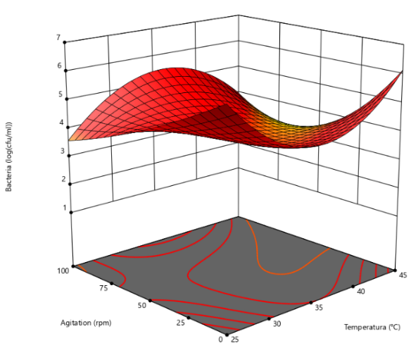  (a) | 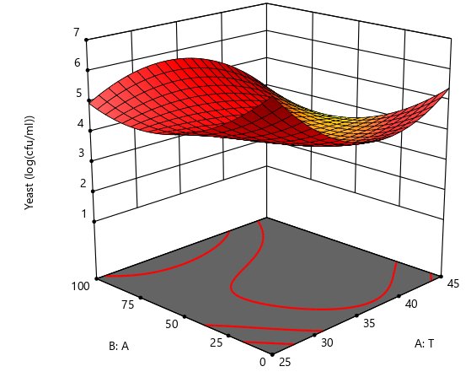  (b)
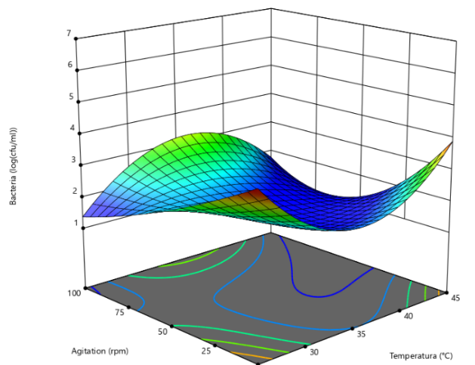  (b) | 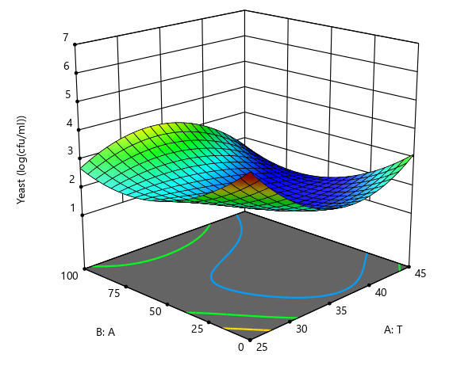  (d)

Figure 1. Response Surface for: (a) concentration of lactic acid bacteria at lower initial biomass, (b) concentration of yeast at lower initial biomass, (c) concentration of lactic acid bacteria at higher initial biomass and (d) concentration of yeast at higher initial biomass.

de Sainz, Figure 2
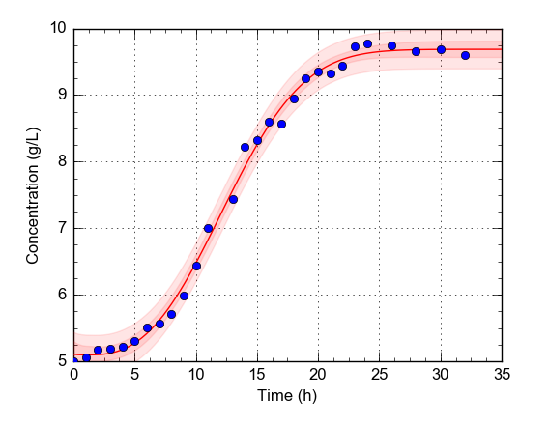

Figure 2. Kinetics of the production of biomass

de Sainz, Figure 3.
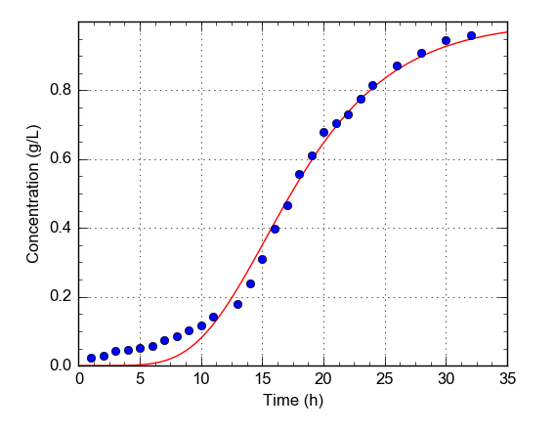

Figure 3. Acid production kinetics

De Sainz, Figure 4.
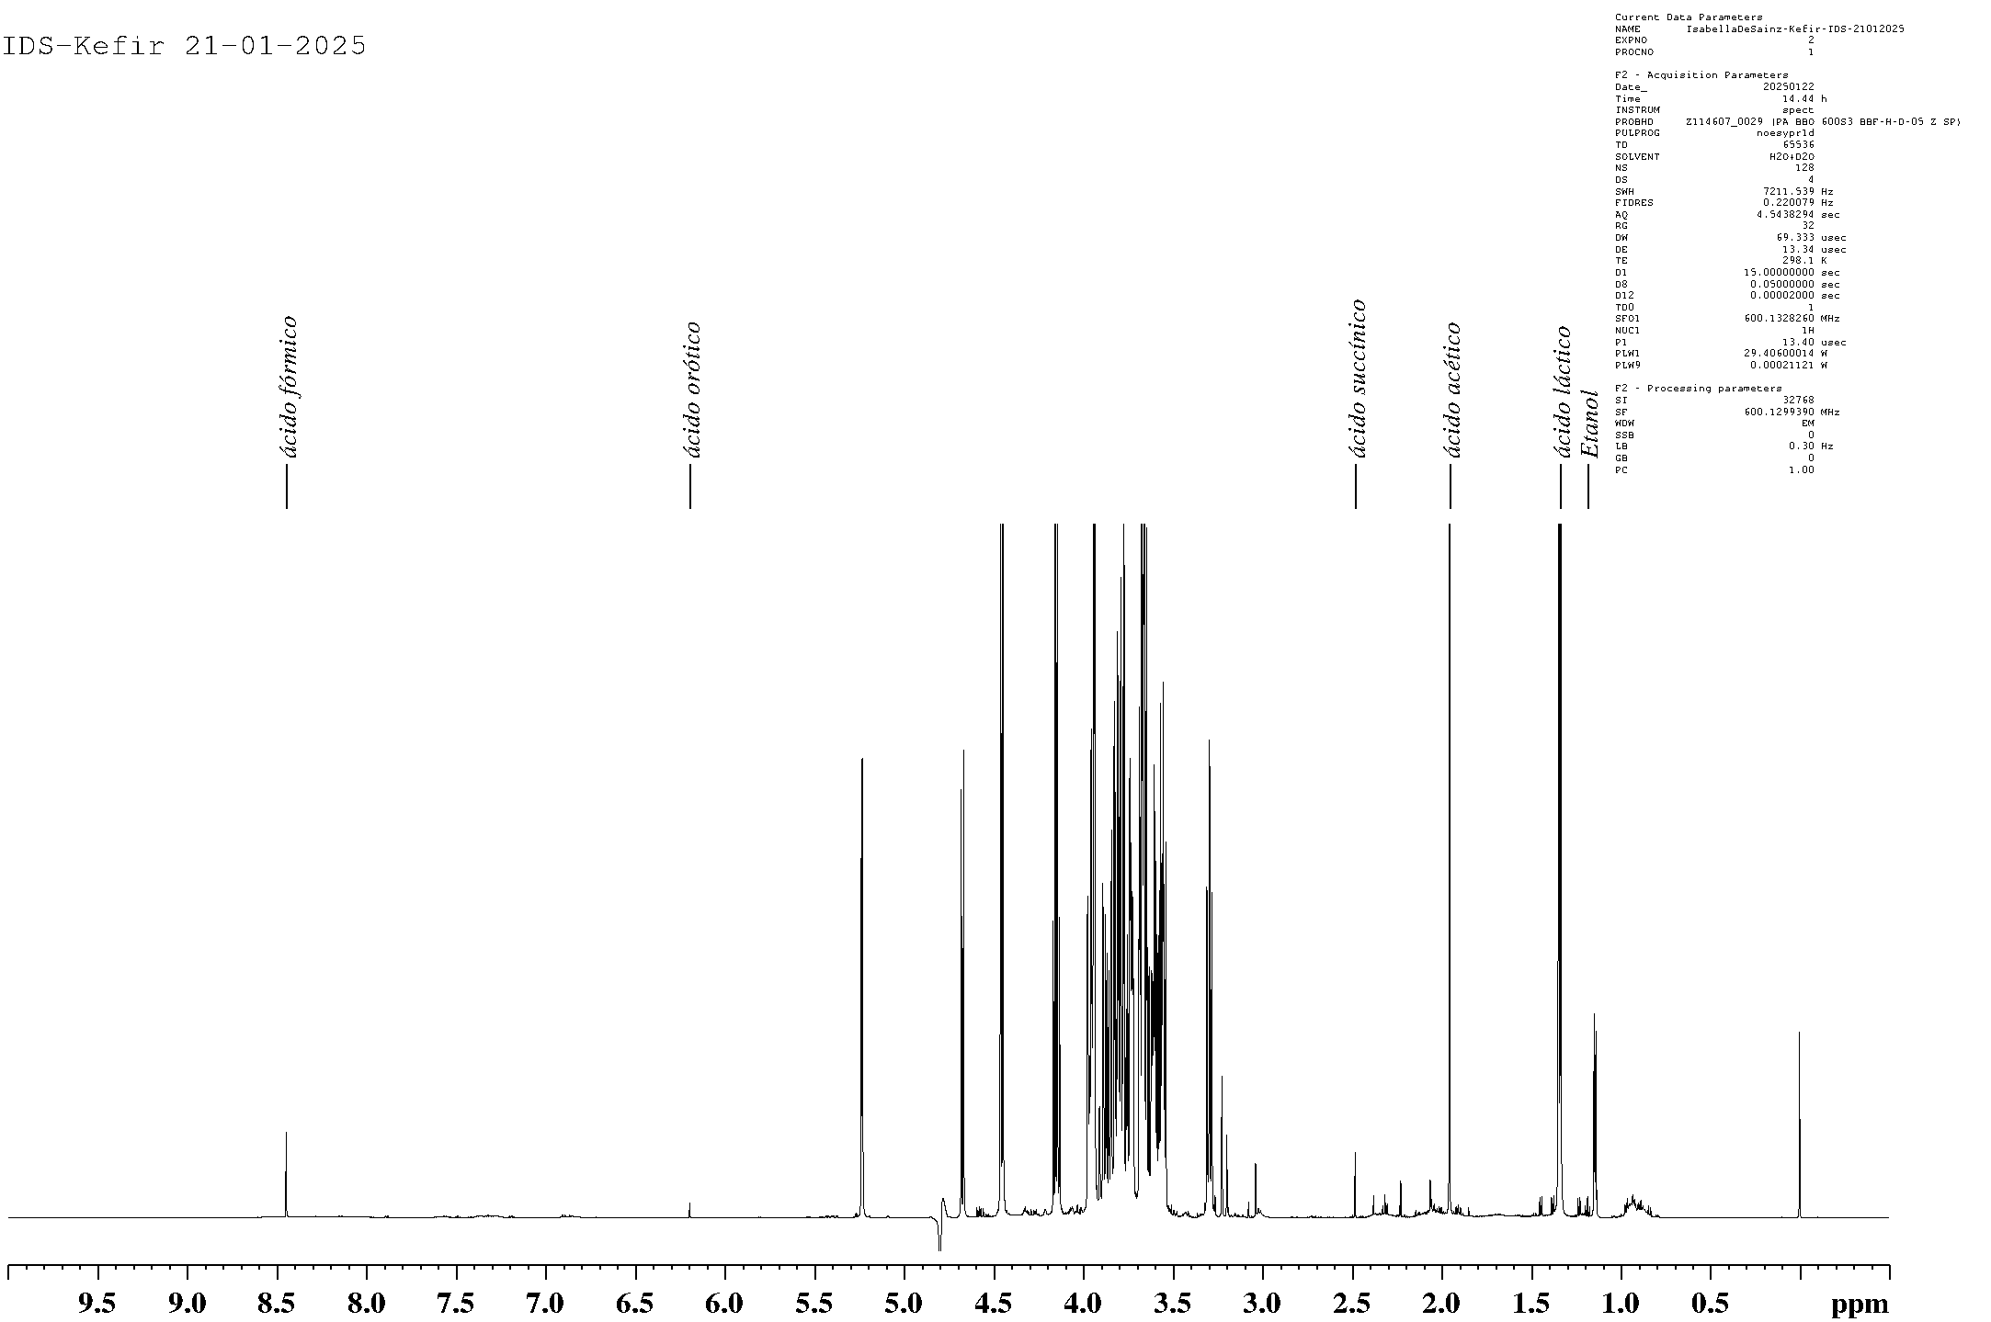

Figure 4. 1H-NMR spectrum of Kefir with indication of the signals used in the quantification of identified compounds

De Sainz, Appendix A
Ejemploccd <- read.table("/Users/isade/Desktop/documentname.txt", header = TRUE)
str(Ejemploccd)

# “documentname” is a text file with the results in Table 1

library(rsm)
Ejemploccd

rsm.Ejemploccd <- rsm(Lev ~ SO(Temp, Agita, Perc), data = Ejemploccd)
rsm.Ejemploccd$studres <- rstudent(rsm.Ejemploccd)
summary(rsm.Ejemploccd)

contour.lm(rsm.Ejemploccd,~Temp+Agita)
contour(rsm.Ejemploccd, ~ Temp + Agita, image=TRUE, at = canonical(rsm.Ejemploccd)$xs, main = "through stationary point")

Appendix A. RStudio Code

